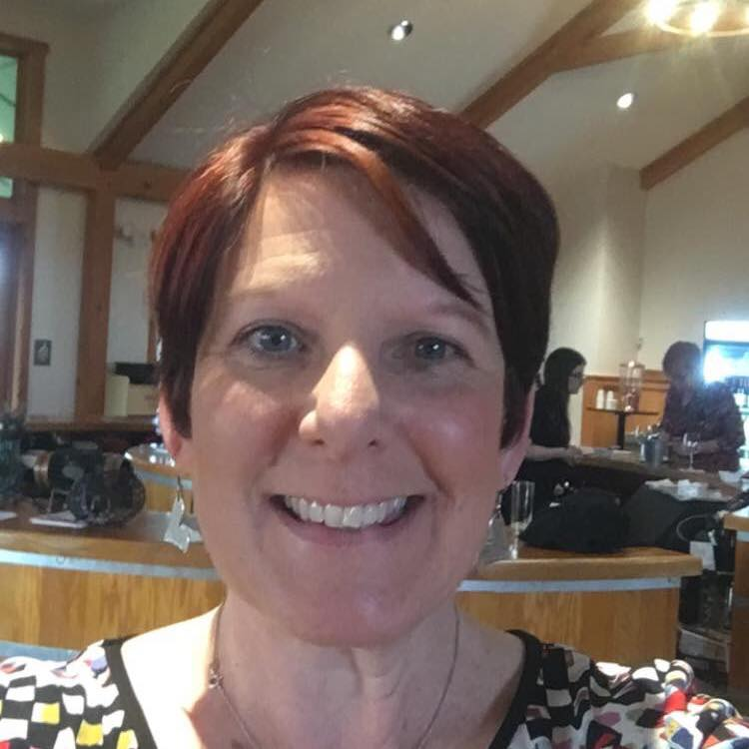 |  |  |  | Jeannine  Luby

Experience
09/2013–present
Part-time Instructor• Teaching Mass Communications Courses • King’s College
06/2015–present
Part-time Grader• Correcting & Grading Speeches, English and Business Writing Assignments • Penn Foster
08/2006–present
Business owner of Laugh to Live, LLC• Professional speaker and wellness workshop leader promoting laughter and humor
12/1999–05/2010
Marketing Communications Specialist• Researched, wrote, coordinated design of member, provider and sales materials such as newsletters, brochures, self-mail pieces • Blue Cross of Northeastern PA

Education
-Marywood University, Scranton, PA – Masters of Communication Arts
-Pennsylvania State University, University Park, PA – Bachelor of Arts in Journalism and a Minor in Sociology

Certification
Positive Psychology

References
[Available upon request.]
2127 Durkin Ave.
Scranton, PA 18508
 |  | 570-650-7518
 |  | jmluby@verizon.net
 |  | JeannineLuby.com

